Name : Sundaramoorthy S
Reg No : 192324228
Course code : Cloud Computing And Big Data Analysis
Exp No : EXPERIMENT 5
Date : 18/12/2025

EXPERIMENT 5
Title
Creation of a Simple Cloud Software Application for SIMATS Library Book Reservation System to Demonstrate SaaS
Aim
To create and deploy a cloud-based Library Book Reservation System for SIMATS library to demonstrate Software as a Service (SaaS).
Procedure
- Select a cloud service provider such as AWS / Firebase / Zoho Creator.
- Create a web-based application for library book reservation.
- Design forms for book details, student details, and reservations.
- Store book and reservation details in a cloud database.
- Deploy the application on the cloud platform.
- Allow students to reserve books through a web browser.
Sample Dataset
- Book ID: L101, Title: DBMS, Author: Korth, Copies: 5
- Book ID: L102, Title: Cloud Computing, Author: Rajkumar Buyya, Copies: 3
Output

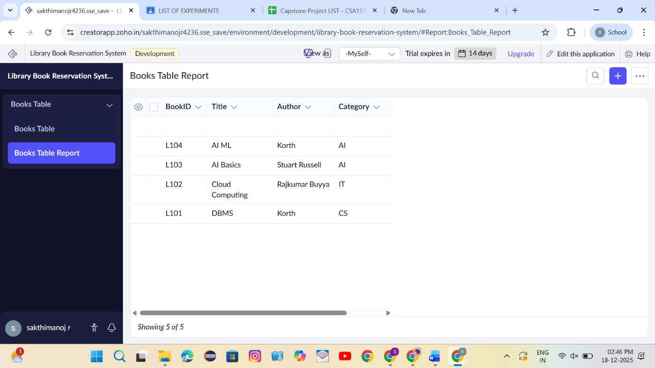
- Library book reservation form displayed online.
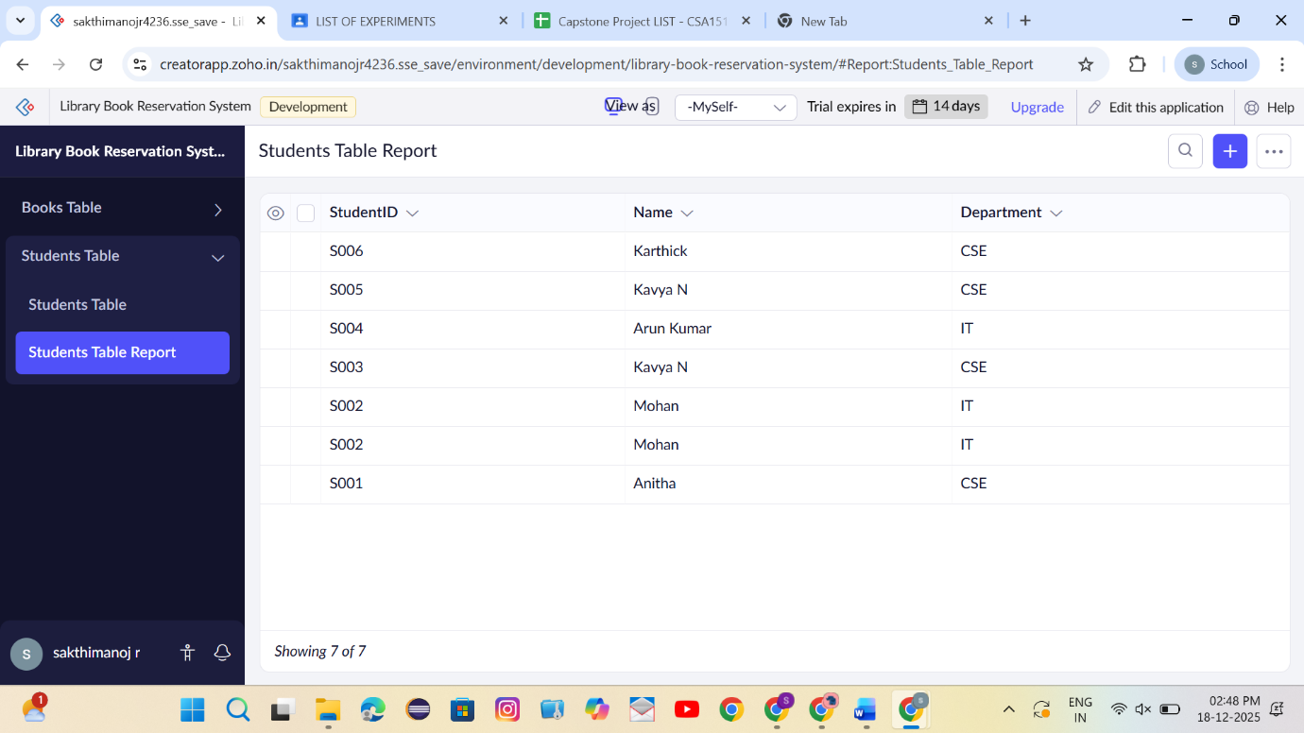
- Reservation details stored in cloud database
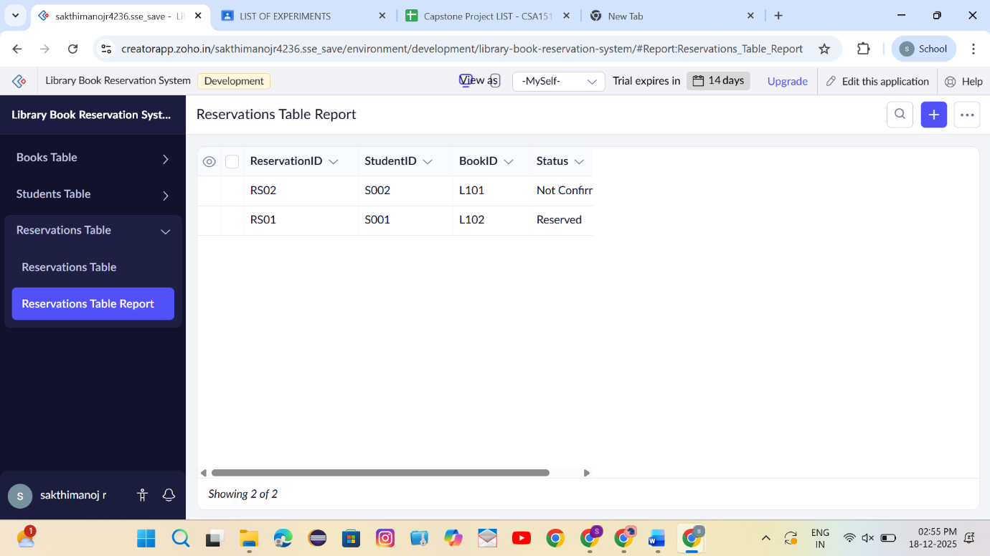
Result
Thus, a cloud-based SIMATS Library Book Reservation System was successfully created and deployed to demonstrate the SaaS model.

